|  |  |  |
| --- | --- | --- |
| **School of Mathematical Sciences**  **Assignment Cover Sheet**  **MATHS: Probability and Statistics** |  | MARK: |

|  |  |  |  |  |
| --- | --- | --- | --- | --- |
| **Tick the box corresponding to the assignment number** | | | | |
| 1 | 2 | 3 | $√$ 4 | 5 |

|  |  |
| --- | --- |
| StudentLast Name | Martin |
| Student First Name | Andrew |
| Student ID | 1704466 |
| Tutorial Day and Time | Tuesday 1pm |

**WARNING**

Remember to sign the plagiarism declaration at the bottom of the page. *If this is not signed, a mark of 0 will be recorded for this assignment.*

PLAGIARISM AND COLLUSION

**Plagiarism:** using another person’s ideas, designs, words or works without appropriate acknowledgement.

**Collusion:** another person assisting in the production of an assessment submission without the express requirement, or consent or knowledge of the assessor.

**NB: In this course you are encouraged to work with other students but the work you submit must be your own. This means you must understand it and be able to explain it if required.**

**CONSEQUENCES OF PLAGIARISM AND COLLUSION**

The penalties associated with plagiarism and collusion are designed to impose sanctions on offenders that reflect the seriousness of the University’s commitment to academic integrity. Penalties may include: the requirement to revise and resubmit assessment work, receiving a result of zero for the assessment work, failing the course, expulsion and/or receiving a financial penalty.

|  |
| --- |
| I declare that all material in this assessment is my own work except where there is clear acknowledgement and reference to the work of others. I have read the University Policy Statement on Plagiarism, Collusion and Related Forms of Cheating (http://www.adelaide.edu.au/policies/?230).  I give permission for my assessment work to be reproduced and submitted to other academic staff for the purposes of assessment and to be copied, submitted and retained in a form suitable for electronic checking of plagiarism.    10/5  Signed………………………………………………. Date …………………………………………… |

2.a

Show that: $E\left[g\left(X\right)h\left(Y\right)\right]=E\left[g\left(X\right)\right]E[h\left(Y\right)]$, knowing that X and Y are independent, continuous random variables with joint pdf $f_{XY}(x,y)$,& marginal pdfs $f_{X}\left(x\right)\& f_{Y}\left(y\right)$.

$$E\left[g\left(X\right)h\left(Y\right)\right]=∫∫g\left(X\right)h\left(Y\right)f_{XY}\left(x,y\right)dxdy \\ =∫\left.∫\left.g\left(X\right)h\left(Y\right)f_{X}\left(x\right)f_{y}\left(y)\right.dxdy\right.\right. \\ =∫g\left(X\right)f_{X}\left(x\right)dx∫h\left(Y\right)f_{Y}\left(y\right)dy \\ =E\left[g\left(X\right)\right]E[h\left(Y\right)]$$

2.b

Assuming $X\sim \exp\left(1\right)$ and $Y\sim \exp\left(2\right)$ find $E\left[e^{\frac{X+Y}{2}}\right]=E\left[e^{\frac{X}{2}}e^{\frac{Y}{2}}\right]$  
 Since X, Y independent, $E\left[e^{\frac{X}{2}}e^{\frac{Y}{2}}\right]=E\left[e^{\frac{X}{2}}\right]E\left[e^{\frac{Y}{2}}\right]$ (from above) $$E\left[e^{\frac{X}{2}}\right]=\int_{0}{e^{\frac{x}{2}}λe^{-λx}dx}=λ\int_{0}{e^{\frac{x}{2}-λx}dx=}λ{{\left[\frac{1}{1/2-λ}e^{\frac{x}{2}-λx}\right]}^{∞}}_{0}=-\frac{λ}{1/2-λ}=\frac{-1}{-\frac{1}{2}}=2$$ Similarly $E\left[e^{\frac{Y}{2}}\right]=-\frac{2}{\frac{1}{2}-2}=-\frac{2}{-\frac{3}{2}}=\frac{4}{3}$ $$∴E\left[e^{\frac{X}{2}}e^{\frac{Y}{2}}\right]=2*\left(\frac{4}{3}\right)=\frac{8}{3}$$

3.a

A sketch of the intersection of the areas $y≥x$ and of $x>0$ as this intersection is the only area where $f\left(x,y\right)$ will be non-zero. i.e. $f\left(x,y\right)=0 if$

$$λ=0 and/or \\ x<0 and/or \\ y<x$$

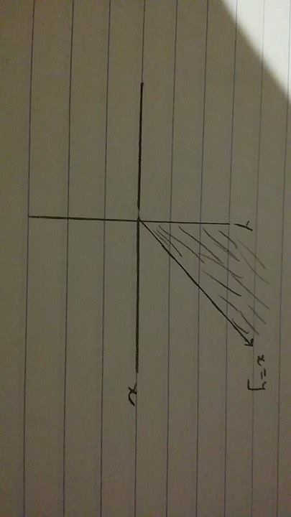

The shaded area satisfies this.

3.b

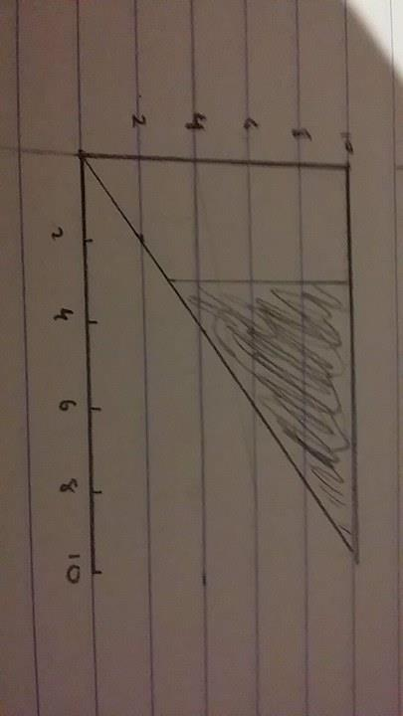

This shaded area – excluding the points along lines $X=3 \& Y=10$ as $X≠3 \& Y≠10$

Area of this triangle $A=\frac{10-3}{2}*\frac{10-3}{2}*\frac{1}{2}$ $$=\frac{7^{2}}{8}=\frac{49}{8}$$

$$f\left(x,y\right)=1^{2}e^{-y}=e^{-y}$$

$$P\left(X>3∩Y<10\right)=\int_{3}^{10}{\int_{x}^{10}{e^{-y}}dydx}=\int_{3}^{10}{\left[-e^{-y}\right]{10 \atop x}dx}=\int_{3}^{10}{-e^{-10}+e^{-x}dx}=\left[-\frac{x}{e^{-10}}-e^{-x}\right]{10 \atop 3} \\ =-\frac{10}{e^{10}}-e^{-3}-\left(\frac{3}{e^{10}}-e^{-10}\right)=\frac{10-2}{e^{10}}-\frac{1}{e^{3}}=\frac{8}{e^{10}}-\frac{1}{e^{3}} \\ ∴P\left(X>3∩Y<10\right)=\frac{8}{e^{10}}-\frac{1}{e^{3}}$$

3.c

Conditional density function:

$$f_{X}\left(x\right)=\int_{0}^{∞}{λe^{- λy}dy}=\left[-e^{-λy}\right]{∞ \atop 0}=-e^{0}=1 \\ f_{Y}\left(y | x\right)=\frac{f_{X,Y}\left(x,y\right)}{f_{X}\left(x\right)}=\frac{λ^{2}e^{-λy}}{f_{X}\left(x\right)}=λ^{2}e^{-λy}$$

4.a

$X_{i}$ are exponentially distributed with means $\frac{1}{λ_{i}}=μ_{i}→λ_{i}=\frac{1}{μ_{i}}$  
MGF of a exponentially distributed random variable $$m_{X_{i}}\left(t\right)=\frac{λ_{i}}{λ_{i}-t}=\frac{1/{μ_{i}}}{1/{μ_{i}}-t}=\frac{1}{1-μ_{i}t}$$

$t<\frac{1}{μ_{i}}$ is needed because the others cannot apply:

If $t>\frac{1}{μ_{i}}→$ ${E[e}^{tx}]<0→ e^{tx}<0$ which is not possible for real $tx$

$t=\frac{1}{μ_{i}}$ Would return $\frac{1}{0}$ which is undefined.

4.b

Joint MGF $m_{X_{1},X_{2}}\left(t_{1},t_{2}\right)=E[e^{t_{1}X_{1}+t_{2}X_{2}}]$ 
   
 since $X_{1}, X_{2}$ indep $E\left[e^{t_{1}X_{1}+t_{2}X_{2}}\right]=E\left[e^{t_{1}X_{1}}\right]E[e^{t_{2}X_{2}}]$

4.c

$S_{n}=\sum_{i=1}{X_{i}}$

$m_{S_{n}}\left(t\right)=m_{X_{1}}\left(t\right)m_{X_{2}}\left(t\right)…m_{X_{2}}\left(t\right)$ $m_{S_{n}}\left(t\right)=\prod_{i=1}^{n}{\frac{1}{(1-μ_{i}t)}}$